

**Question/Answer Booklet**

**Name:**

**PHYSICAL EDUCATION STUDIES**

**Yr 11 ATAR**

**Biomechanics Validation**

**Time allowed for this paper**

Working time for paper: 55 minutes

**Material required/recommended for this paper**

***To be provided by the supervisor***

This Question/Answer Booklet

|  |  |  |  |
| --- | --- | --- | --- |
| **Contents:**  Functional Anatomy | Multiple choice  Short answers  Extended question | marks  marks  marks  **Total marks** | **/** |

**Multiple Choice (5 marks)**

1. Velocity is calculated by

(a) dividing distance travelled by time taken.

(b) dividing displacement by time taken.

(c) multiplying distance travelled by time taken.

(d) multiplying displacement by time taken.

2. A baseball player fields the ball near second base and must get the ball to first base as quickly as possible to get the batter out. The player should throw with a

(a) high trajectory and high velocity.

(b) flat trajectory and high velocity.

(c) release angle of 45 degrees.

(d) high trajectory and low velocity.

3. When an object is thrown from a height that is greater than the landing height, the optimal angle of release to reach maximum distance is

(a) 45 degrees.

(b) greater than 45 degrees.

(c) less than 45 degrees.

(d) 90 degrees.

4. Internal forces are produced by

(a) gravity

(b) friction

(c) muscles

(d) air resistance

5. The statement ‘an object at rest will remain so unless acted on by a force’ is an example of

(a) Newton’s first law

(b) Newton’s second law

(c) Newton’s third law

(d) none of the above

6. The greater an object’s mass

(a) The greater it’s inertia

(b) The greater the force required to accelerate it

(c) The greater it’s resistance to change it’s state of motion

(d) All of the above

7. In order to summate forces effectively;

(a) The muscles with the least inertia should initiate the movement

(b) The muscles with the greatest inertia should initiate the movement

(c) The faster muscles should be utilised first

(d) The larger muscles should apply their forces towards the end of the movement to produce power

8. Linear motion occurs in;

(a) A straight line where all parts move in the same direction, same time at the same speed

(b) A curved or straight line where all parts move in the same direction, same time at the same speed

(c) A curved line where all parts move in the same direction, same time at the same speed

(d) A straight or curved line where all parts move in the same direction, same time, same displacement

9. Rotation only is caused by;

(a) An eccentric force

(b) A concentric force

(c) A force couple

(d) A translation force

10. When a body is at rest, it is in a state of;

(a) Dynamic equilibrium

(b) Static equilibrium

(c) Mobile equilibrium

(d) Gravitational equilibrium

**Part B – Short Answer – Write the answer to each question in the space provided. 48 marks**

**Question 13 3 marks**

a. Force absorption relates to which of Newton’s laws of motion?___________________________

b. What two factors are important for the absorption of force when catching a ball?

•_________________________________ •_____________________________________

**Short Answer (20 marks)**

**Question 6 (3 marks)**

Cycling is a good example of general motion. Explain this statement.

**Question 7 (7 marks)**

A set of golf clubs contains woods and irons. The image below shows a set of irons. The iron closest to the ball is called a ‘9 iron’ and the iron on the far left is called a ‘1 iron’.

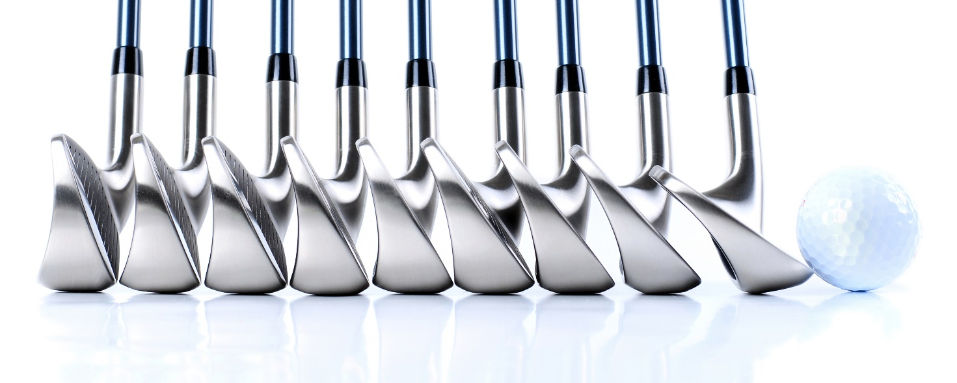

(a) Explain why a golfer would have a range of irons, from a 1 iron to a 9 iron, in their golf bag. (4 marks)

(b) Woods are designed with longer shafts than irons. Use your knowledge of angular velocity to explain the benefit of using a wood as opposed to an iron. (3 marks)

**Question 8 (3 marks)**

The images below show a sprinter preparing for the start of a race. With reference to centre of gravity and base of support, discuss how a sprinter changes their body position (from image 1 to image 2) to manipulate their stability and ensure that they have the most successful race start.

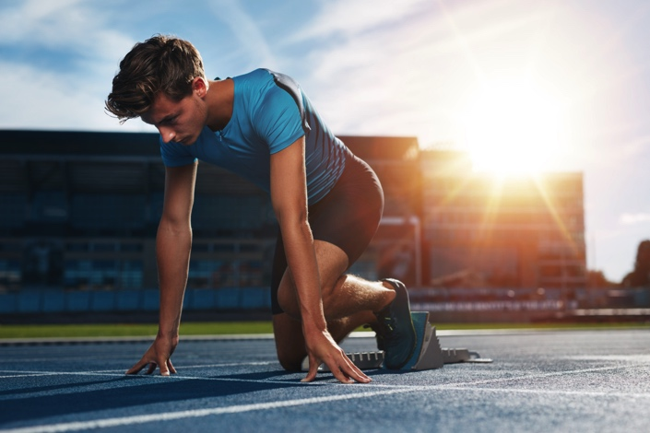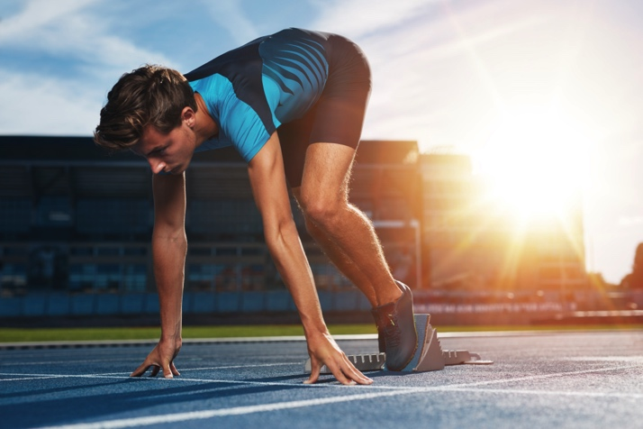

Image 1 Image 2

**Question 9 (4 marks)**

Weighted vests can be worn by athletes to increase their workload during a training session. Wearing a weighted vest makes exercises where the athlete is required to overcome gravity more demanding and therefore can increase training benefits. With reference to Newton’s Third Law of Motion, explain why an athlete may also increase their risk of injury by wearing a weight vest for activities such as running.

**Question 10 (3 marks)**

In basketball, most competitive teams will allocate players to set roles. Commonly used terms for describing the roles of players on a basketball team are guards, forwards and centres. Generally, guards tend to be the shortest players on the team and are relied on for their speed and agility. The centres are usually taller and play close to the ring, gathering rebounds and contesting shots. Explain why guards are often shorter than centres.

**Question 14 6 marks**

The optimal angle of projection for maximum horizontal distance is usually 45°. For the following activities, explain whether the optimum angle is more, less or equal to 45° and why this is the case

1. Shot put _____________________________________________________________

____________________________________________________________________

____________________________________________________________________

1. Long jump ____________________________________________________________

____________________________________________________________________

____________________________________________________________________

1. High jump ____________________________________________________________

____________________________________________________________________

____________________________________________________________________

**Question 15 3 marks**

Define Newton’s first law of motion and apply it to a golfer hitting their shot off the tee

_________________________________________________________________________

_________________________________________________________________________

_________________________________________________________________________

_________________________________________________________________________

_________________________________________________________________________

_________________________________________________________________________

**Question 16 6 marks**

List and describe the four (4) factors that influence stability

•________________________________________________________________________

_________________________________________________________________________

•________________________________________________________________________

_________________________________________________________________________

•________________________________________________________________________

_________________________________________________________________________

•________________________________________________________________________

_________________________________________________________________________

**Question 17 6 marks**

A footballer tries to bump an opponent to knock him off balance in a tackle. Explain how this is achieved using a diagram to illustrate your answer.

_________________________________________________________________________

_________________________________________________________________________

_________________________________________________________________________

_________________________________________________________________________

**Question 18 4 marks**

Explain the concept of Newton’s second law and apply it to a sport of your choice

_________________________________________________________________________

_________________________________________________________________________

_________________________________________________________________________

_________________________________________________________________________

_________________________________________________________________________

_________________________________________________________________________

**Question 19 3 marks**

Newton’s third law states ‘that for every action, there is an equal and opposite reaction’. Use this law to explain how an athlete can pass a touch rugby ball.

_________________________________________________________________________

_________________________________________________________________________

_________________________________________________________________________

_________________________________________________________________________

_________________________________________________________________________

_________________________________________________________________________

**Question 20 3 marks**

A gymnast claims to be able to place their centre of gravity outside their body. Explain what this means and, with the use of a diagram, if this is possible or not.

_________________________________________________________________________

_________________________________________________________________________

_________________________________________________________________________

**Question 21 5 marks**

Explain simultaneous summation of force and use sporting examples to explain how simultaneous summation can be used to produce power or accuracy

_________________________________________________________________________

_________________________________________________________________________

_________________________________________________________________________

_________________________________________________________________________

_________________________________________________________________________

_________________________________________________________________________

**Question 22 2 marks**

A run-up serves to maximise the distance a kicked AFL football travels. Explain how this occurs

_________________________________________________________________________

_________________________________________________________________________

_________________________________________________________________________

_________________________________________________________________________

_________________________________________________________________________

_________________________________________________________________________

**Question 11 (10 marks)**

The application of sequential and simultaneous movement depends on the nature of the action being performed. Describe sequential movement and simultaneous movement. Providea specific example where each movement would be preferred. Justify your response.

**End of questions**

**MARKING KEY**

|  |  |
| --- | --- |
| logo | **Year 11 ATAR Physical Education Studies** |
| **Task 8 – Validation - Biomechanics** |

**Part A – Multichoice Questions – Clearly circle the desired letter corresponding to your answer (10 marks)**

|  |  |  |  |  |  |  |  |  |  |
| --- | --- | --- | --- | --- | --- | --- | --- | --- | --- |
| **1** | **2** | **3** | **4** | **5** | **6** | **7** | **8** | **9** | **10** |
| C | A | D | B | B | A | C | B | A | C |

**Part B – Short Answer – Write the answer to each question in the space provided. (48 marks)**

**Question 11 4 marks**

Analyse force summation graph and explain which option will produce the best throw

|  |  |
| --- | --- |
| **Description** | **Marks** |
| a. **1 mark** for identifying summation of force/velocity  b. **1 mark** to identify ‘C’ as the most effective throw  **1 mark** - explain body segments are sequentially added at the peak velocity of previous segment  **1 mark** - explain that larger, slower segments are used first, followed by smaller, faster segments | 1  1  1  1 |

**Question 12 3 marks**

List 3 external forces that can act on a body

|  |  |
| --- | --- |
| **Description** | **Marks** |
| **1 mark each** for – gravity, friction, air resistance or water resistance | 1 |

**Question 13 3 marks**

Force absorption relates to which of Newton’s laws of motion?

|  |  |
| --- | --- |
| **Description** | **Marks** |
| a. **1 mark** – identify second law of motion  b. **1 mark each** – velocity and time | 1  1-2 |

**Question 14 6 marks**

Explain optimum angle (more, less or equal to 45°) for various skills

|  |  |
| --- | --- |
| **Description** | **Marks** |
| a. **1 mark** – shot put is less than 45°, **1 mark** – due to increased height of release  b. **1 mark** – long jump less than 45°, **1 mark** – it is more important to maintain horizontal velocity  c. **1 mark** – high jump greater than 45°, **1 mark** – vertical velocity more important to get over bar | 1-2  1-2  1-2 |

**Question 15 3 marks**

Define Newton’s first law of motion and apply it to a golfer hitting their shot off the tee

|  |  |
| --- | --- |
| **Description** | **Marks** |
| **1 mark** – law defined as ‘an object at rest will stay at rest, an object in motion will stay in motion in the same direction and velocity until an unbalanced force acts on it’  **1 mark** – golf ball will sit on the tee, at rest, until acted upon by an external force (golf club)  **1 mark** – once it has been hit, the ball will continue to travel in the same direction at the same velocity until an unbalanced force acts on it (gravity, air resistance and the ground when it lands) | 1  1  1 |

**Question 16 6 marks**

List and describe the four (4) factors that influence stability

|  |  |
| --- | --- |
| **Description** | **Marks** |
| **½ mark each** to identify the 4 factors**, 1 mark** for adequate description of each factor  a. **mass** – generally, the greater the mass, the greater stability of an object  b. **area of base of support** – the greater the area of the base of support, the greater stability  c. **height of centre of gravity** – the lower the centre of gravity, the greater stability  d. **line of centre of gravity in relation to base of support** – the closer the line of gravity to the centre of the base of support, the greater the stability | ½-1½  ½-1½  ½-1½  ½-1½ |

**Question 17 6 marks**

Explain how you would knock a footballer off balance – use diagrams

|  |  |  |
| --- | --- | --- |
| **Description** | | **Marks** |
| **1 mark** – explain how body is stable while running in football (line of gravity over base of support)  **1 mark** – explain loss of balance - falling over (line of gravity outside base of support)  **1 mark** – achieved by application of eccentric force (eg. tackle) within rules of sport  **1 mark** – applied force needs to be sufficient to move line of gravity outside the base of support | | 1  1  1  1 |
|  | **Diagram – ½ mark each for following**  Purple box – representation of football player  Black dot – centre of gravity  Red line – line of gravity  Blue arrow – direction and size of force application | ½  ½  ½  ½ |

**Question 18 4 marks**

Explain the concept of Newton’s second law and apply it to a sport of your choice

|  |  |
| --- | --- |
| **Description** | **Marks** |
| **1 mark** – law states ‘the acceleration of an object is directly related to the net force and inversely related to its mass’ F=ma without further explanation is not sufficient  **1 mark** – a force (greater than inertia) is applied to an object to get it to move in a certain direction  **1 mark** – the more force is applied, the greater the acceleration of the object (drop shot v drive)  **1 mark** – correct application to a sporting example of choice | 1  1  1  1 |

**Question 19 3 marks**

Use Newton’s 3rd law to explain what happens when a player kicks a soccer ball.

|  |  |
| --- | --- |
| **Description** | **Marks** |
| **1 mark** – the action force is the athlete applying a force to the ball (generated by muscles)  **1 mark** – the reaction force is equal in magnitude but opposite in direction (ball applies equal and opposite force back on the players foot)  **1 mark** – the athlete has a greater mass so is less affected by the reaction (the ball accelerates and the foot decelerates as a result of the action:reaction forces | 1  1  1 |

**Question 20 3 marks**

Explain how a gymnast can place their centre of gravity outside their body

|  |  |  |
| --- | --- | --- |
| **Description** | | **Marks** |
| **1 mark** – definition ‘imaginary point about which all of the body’s mass is equally distributed’  **1 mark** – by manipulating the position of body segments, centre of gravity can act outside the body | | 1  1 |
|  | **Diagram**  **1 mark –** accurately shows centre of gravity outside the body (other variations possible) | 1 |

**Question 21 5 marks**

Explain simultaneous summation of force, use sports examples to produce power or accuracy

|  |  |
| --- | --- |
| **Description** | **Marks** |
| **1 mark** – simultaneous summation IS body segments reaching peak velocity at the same time  **1 mark** – accuracy requires fewer segments and lower velocity but movement all at the same time  **1 mark** – relevant example (throwing a dart, shooting in netball, shot in pool/snooker, or others)  **1 mark** – power requires all segments applying max velocity at the same time  **1 mark** – relevant example (weightlifting, high jump take off, vault take-off) | 1  1  1  1  1 |

**Question 22 2 marks**

A run-up serves to maximise the distance a kicked AFL football travels. Explain how this occurs

|  |  |
| --- | --- |
| **Description** | **Marks** |
| **1 mark** – to maximise the range of a kick (horizontal distance), the footballer applies both horizontal and vertical velocity to the ball at an optimal projection angle (near 45°)  **1 mark** – a run-up serves to increase horizontal velocity which is added to the horizontal velocity of the kicking action thereby increasing horizontal velocity at release, making it travel further | 1  1 |